
Company
Logotype

Cone Beam Computed Tomography- Report



Porur Dental X-rays & CBCT

Patient Name : Mrs. Seethalakshmi | Date of Report : 23.06.2025
Age/ Gender : 69 years/ Female | Region of Interest : CBCT Full Skull
Referring doctor: Dr. Selva Ganesh | Indication : Implant assessment
Clinical Notes: Nil
PATIENT INFORMATION

CBCT- Full Skull provided
CBCT – IMAGE DETAILS

RADIOGRAPHIC INTERPRETATION

- Complete loss of crown and root structure in relation to 12, 14, 15, 16, 24, 26, 27, 28, 36, 37, 46, 47, 48
- Root stumps in relation to 42
- The alveolar ridge in relation to the maxillary and mandibular alveolar ridge is present with resorptive changes causing reduced height of the alveolar ridge.

IMPLANT ASSESSMENT

 | 12 region | 14 region | 23 region
Sub-Crestal | 2.3 | 3.3 | 2.8
Mid- Crestal | - | - | 4
Distance between the alveolar ridge and Floor of the Nasal cavity (in mm) | 7.9 | 7.1 | 12.3

 | 15 region | 16 region | 25 region | 26 region | 27 region
Sub-Crestal (in mm) | 3.3 | - | - | - | -
Mid- Crestal (in mm) | - | - | - | - | -
Distance between the alveolar ridge and floor of the maxillary sinus (in mm) | 5.7 | 1.2 | 0.5 | 0.7 | 1.2

 | 36 region | 37 region | 46 region | 47 region
Sub-Crestal (in mm) | 2.4 | 4.3 | 4.3 | 5.5
Mid- Crestal (in mm) | 4.5 | 7.8 | 4.9 | 8.3
Distance between alveolar ridge and the inferior alveolar nerve canal (in mm) | 12.8 | 9.5 | 10.7 | 8.6
Distance between alveolar ridge and the inferior border of mandible (in mm) | 23.3 | 20.4 | 22 | 19.6

RADIOGRAPHIC IMPRESSION

- Partially edentulous maxillary and mandibular arch.
- Root stumps: 42

Kindly correlate with clinical findings


IMAGES FOR REFERENCE

RECONSTRUCTED PANORAMIC VIEW

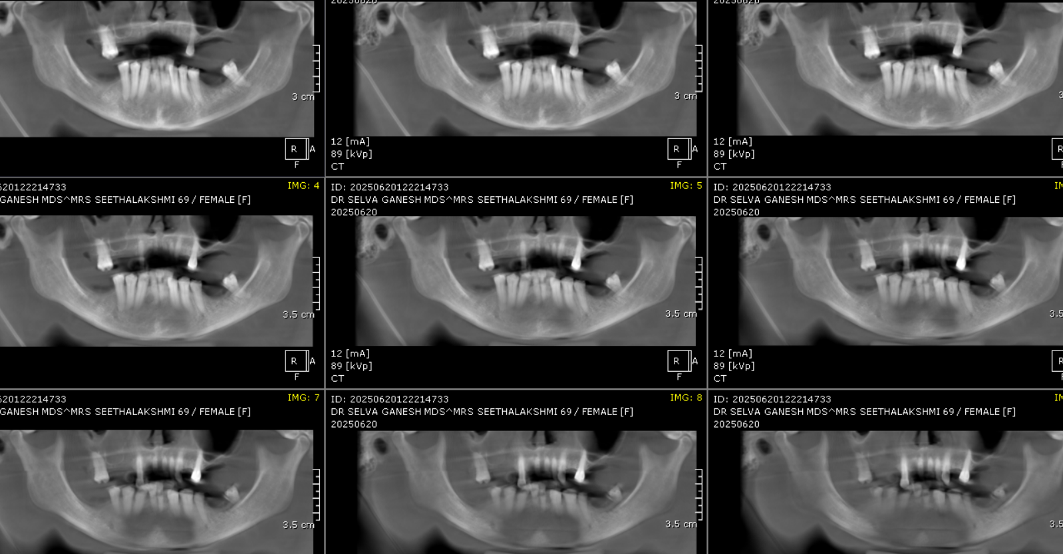

3-DIMENSIONAL VIEW

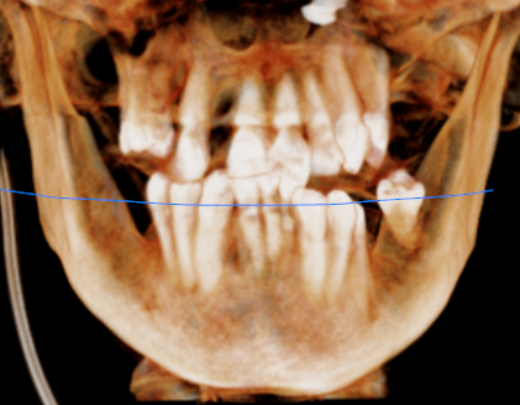
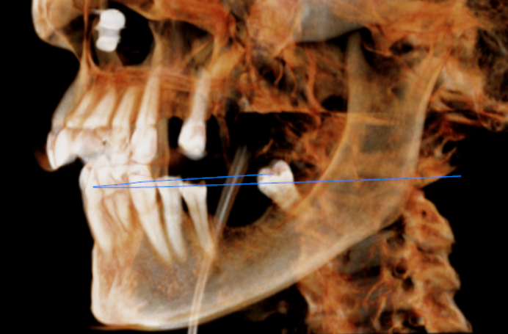

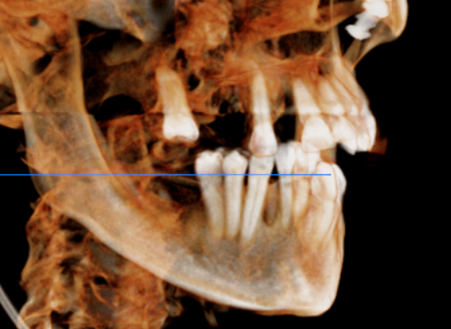

CROSS SECTIONAL VIEW

12 region | 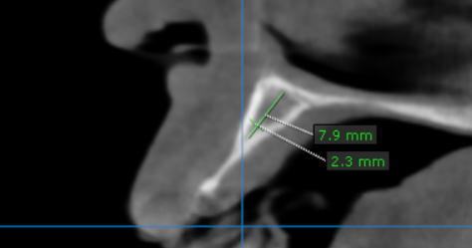
14 region | 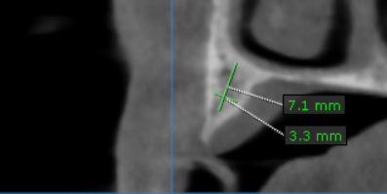
15 region | 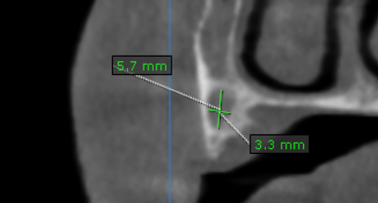
16 region | 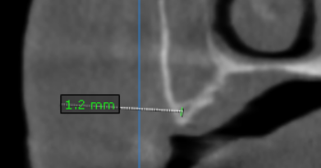
23 region | 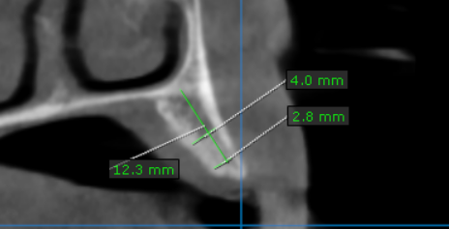
25 region | 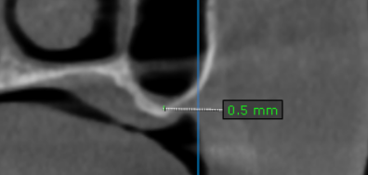
26 region | 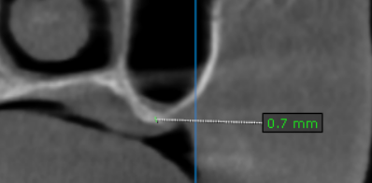
27 region | 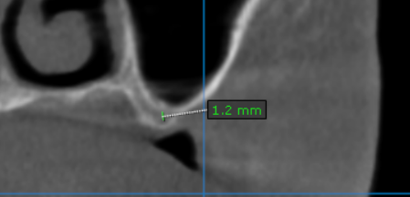
36 region | 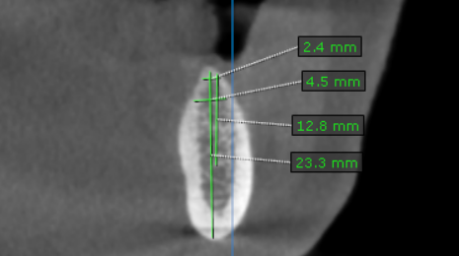
37 region | 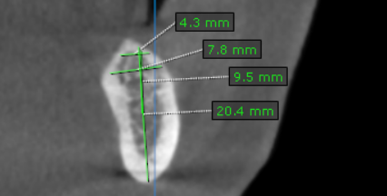
46 region | 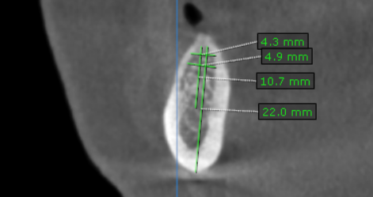
47 region | 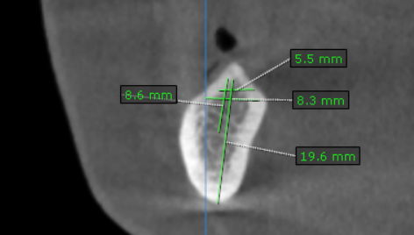

**** End of report ****

